 |  |  |  |  |  |  |  |  |  | curriculum.newvisions.org/social-studies  Timothy Lent - tlent@newvisions.org  Kameelah Rasheed - krasheed@newvisions.org | 
Please Read: We encourage all teachers to modify the materials to meet the needs of their students. To create a version of this document that you can edit:  1. Make sure you are signed into a Google account when you are on the resource.  2. Go to the "File" pull down menu in the upper left hand corner and select "Make a Copy." This will give you a version of the document that you own and can modify. |  |  |  |  |  |  |  |  |  |  | 
Teacher Overview: What cultural effects did the Renaissance and the printing press have in northern Europe?
Go directly to student-facing materials!

 | SQ 7. Why and how did the Renaissance spread outside of Italy? | SQ 8. What cultural effects did the Renaissance and the printing press have in northern Europe? |  | SQ 9. What was the Protestant Reformation? What were the causes? | 

 | Unit Essential Question(s): How did new ideas and innovation affect Western Europe and Russia starting in the 15th century? | Link to Unit
Supporting Question(s):
- What cultural effects did the Renaissance and the printing press have in northern Europe?
Objective(s):
- Describe the cultural effects of the Renaissance and the printing press on northern Europe.

1. NYS Social Studies Framework:
Key Idea | Conceptual Understandings | Content Specifications
9.9 TRANSFORMATION OF WESTERN EUROPE AND RUSSIA: Western Europe and Russia transformed politically, economically, and culturally ca. 1400–1750. This transformation included state building, conflicts, shifts in power and authority, and new ways of understanding their world.  (Standards: 2, 3, 5; Themes: ID, MOV, TCC, GOV, CIV, TECH, EXCH) | 9.9a The Renaissance was influenced by the diffusion of technology and ideas. The Islamic caliphates played an important role in this diffusion. | Students will investigate technologies and ideas, including printing and paper, navigational tools, and mathematics and medical science that diffused to Europe, noting the role of the Islamic caliphates.  Students will explore shifts in the Western European Medieval view of itself and the world as well as key Greco-Roman legacies that influenced Renaissance thinkers and artists.

2. Social Studies Practices
NYS Social Studies Practices | New Visions Student Social Studies Practices
Gathering, Using and Interpreting Evidence (A2, A5, A7)  Chronological Reasoning and Causation (B1, B5, B7)  Comparison and Contextualization (C1, C3, C5, C6)  Geographic Reasoning (D1, D2, D5) |   Contextualize Connecting Cause and Effect

3. Common Core
Reading | Writing | Speaking and Listening
Craft and Structure:  CCSS.ELA-LITERACY.RH.9-10.4: Determine the meaning of words and phrases as they are used in a text, including vocabulary describing political, social, or economic aspects of history/social science.  Integration of Knowledge and Ideas:  CCSS.ELA-LITERACY.RH.9-10.7: Integrate quantitative or technical analysis (e.g., charts, research data) with qualitative analysis in print or digital text. | Text Types & Purposes:  CCSS.ELA-LITERACY.WHST.9-10.1: Write arguments focused on discipline-specific content. | Comprehension and Collaboration:  CCSS.ELA-LITERACY.SL.9-10.1: Initiate and participate effectively in a range of collaborative discussions (one-on-one, in groups, and teacher-led) with diverse partners on grades 9-10 topics, texts, and issues, building on others' ideas and expressing their own clearly and persuasively.

Associated Classroom Posters
Student Social Studies Practices Poster

Objective: | What cultural effects did the Renaissance and the printing press have in northern Europe?  - Describe the cultural effects of the Renaissance and the printing press on northern Europe.

  Predict | Introduction  ➡ Directions: Examine the image below, then complete the See-Think-Wonder activity.

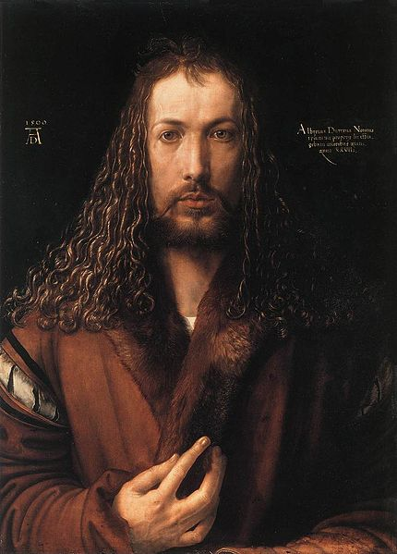  Albrecht Dürer self portrait, 1500.  mage is courtesy of Wikimedia Commons and is public domain. | See  Identify three things you observe about the image to the left.
Think
Based on your observations, what do you think about the artist who created the painting to the left? How does it differ from paintings you have seen from the Italian Renaissance?
Wonder
Write two questions you have about the painting to the left.

Connect Cause and Effect | What cultural effects did the Renaissance and the printing press have in northern Europe?  ➡ Directions: Examine the images and read the text below, then answer the accompanying questions.
Oil Painting
Italian Renaissance artists expressed themselves in sculpture and painted using fresco, a method that involves adding pigments mixed with water to wet plaster, and tempera, a method of painting in which pigments are mixed with egg to produce paint. The artists north of Italy started using oil-based paints. Oil painting gave artists the tools they needed to use a greater variety of colors which gave them the ability to paint more realistic scenes. The paintings below demonstrate the subtle differences in color and shades of light and dark that can be achieved using oil-based paints.
"Analysis of the Art of Renaissance Italy." ItalianRenaissance.org, n.d. Web. 1 Aug. 2017.

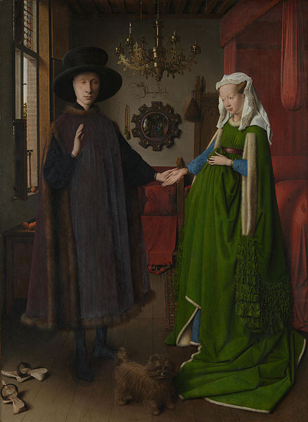  A section of Untitled also known as The Arnolfini Portrait, by Jan Van Eyck, 1434.  Image is courtesy of Wikimedia Commons and is public domain.7. | 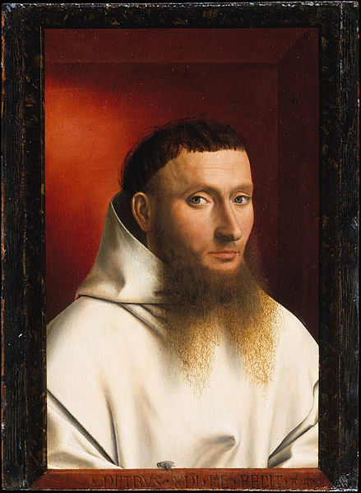  Section of Portrait of a Carthusian by Petrus Christus, 1446.  Image is courtesy of Wikimedia Commons and is public domain.
1. Based on the text and images above, how did art in northern Europe differ from art in Italy during the Renaissance?

Religious and Secular Topics
Like Renaissance artists in Italy, northern European artists depicted both religious and secular scenes.
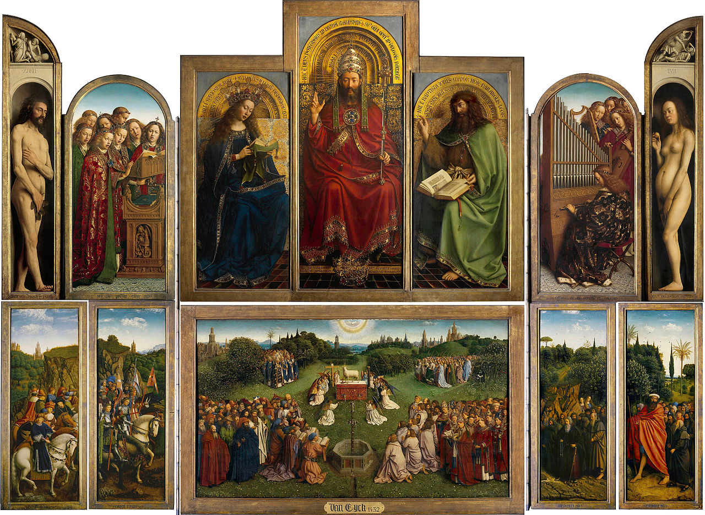  A section of The Ghent Altarpiece (1430-1432) painted by  Jan van Eyck and Hubert van Eyck, depicting God, the Virgin Mary, and John the Baptist.  Image is courtesy of Wikimedia Commons and is public domain. | 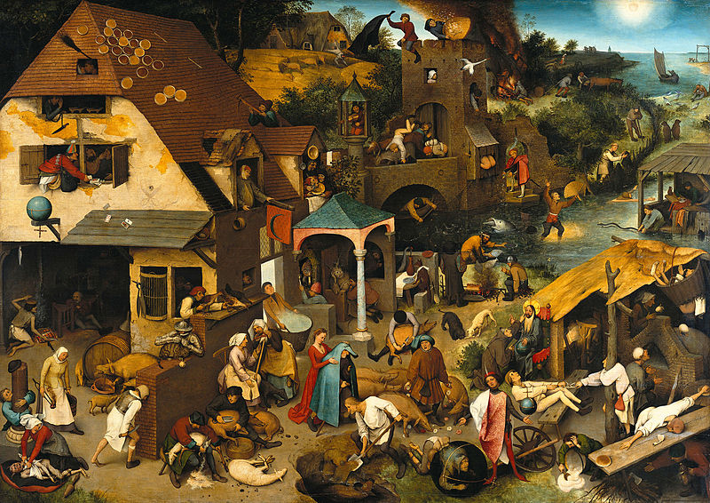  Pieter Brueghel the Elder, a Dutch artist, painted scenes of everyday life for peasants. The Dutch Proverbs, 1559.  Image is courtesy of Wikimedia Commons and is public domain.

2. Based on the text and images above, how was art in northern Europe and Italy similar during the Renaissance?

Mass Production Using the Printing Press
In 1450, Johannes Gutenberg invented the movable-type printing press. That technology soon caught on and was used by artists in northern Europe as well as writers. Artists found success in creating woodblock engravings, then hiring printers to make copies of them, so artists could sell them for a profit. One of the most success artists of the time was Albrecht Dürer. In addition to being an accomplished oil painter, Dürer was also a master engraver. He created carefully etched wood-blocks of religious and secular subjects. He was also one of the first artists to “brand” his artwork. Every Dürer print had his mark, his initials with the A over the D, on it so purchasers knew it was authentic.

One of Dürer’s most famous engravings is the depiction of an Indian Rhinoceros pictured below. In 1515, for the first time since the Roman Empire, a Rhinoceros was brought to Europe. It was shipped from India for the King of Portugal and displayed for the public. Dürer never saw the animal but instead based his drawing on another person’s description. Dürer’s depiction of the rhinoceros was incredibly popular and was circulated throughout Europe. For centuries it appeared in science texts and student textbooks until another rhinoceros was brought to the continent in 1751. Though Dürer’s illustration has errors, like the horn on the animal’s back, it demonstrates the influential power of art and printing through its ability to shape how Europeans imagined one animal for hundreds of years.
"Rhinocerus (Rhinoceros)." The British Museum: Collection Online. The British Museum, n.d. Web. 1 Aug. 2017.
"Johannes Gutenberg." Wikipedia: The Free Encyclopedia. 22 July 2017. Web. 1 Aug. 2017.
Sherwin, Skye. "Albrecht Dürer’s The Rhinoceros: the most influential animal picture ever?" The Guardian. Guardian News and Media Limited, 11 Nov. 2016. Web. 1 Aug. 2017.

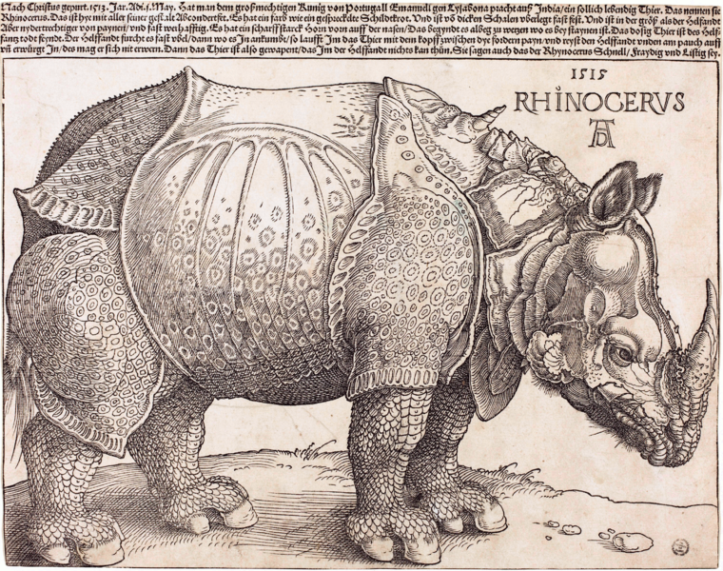  The Rhinoceros, wood-block engraving, Albrecht Dürer, 1515.  Image is courtesy of Wikimedia Commons and is public domain. | 3. What technology expanded the influence of artists and writers in northern Europe during the Renaissance?
 | 4. What does the story of Dürer’s Rhinoceros tell you about northern Europe during the 1500s, and the impact of the printing press on art and the communication of knowledge?

Renaissance Music
 | Listen to Ave Maris Stella by Guillaume Dufay and Ave Maria by Josquin des Prez then read the text and examine the image below.
In addition to the visual arts, music experienced a rebirth during the Renaissance and was especially prominent in England and northern Europe. Composers like Guillaume Du Fay (1397–1474) and Josquin des Prez (ca. 1450–1521) were employed by wealthy nobles and royalty to write religious and secular music for their courts. The trade between northern Europe, Italy, and Spain created a European musical culture that had not existed before. In addition, composers made use of the new printing technology to produce copies of their sheet music and distribute them for money.

Arkenberg , Rebecca . "Music in the Renaissance ." Music in the Renaissance. New York: The Metropolitan Museum of Art, Oct. 2002. Web. 1 Aug. 2017.
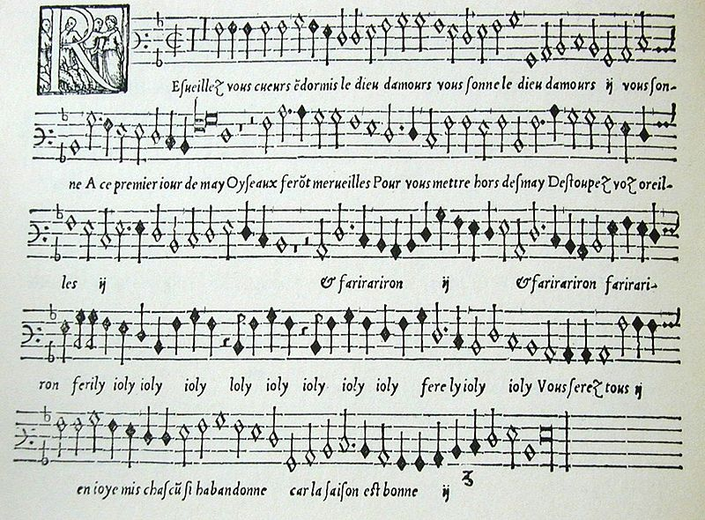  An example of sheet music produced on a printing press from a woodblock engraving from 1545.  Image is courtesy of Wikimedia Commons and is public domain. | 5. What effect did the printing press have on music during the Renaissance?

William Shakespeare (1564-1616)
Watch Simple Show Foundation’s video “William Shakespeare- In a Nutshell” and read the transcript below, then answer the accompanying questions.

Well known, "The Bard" was an English author of famous plays about a lot of different things and he lived during the Elizabethan era.  (0:17) Born in England in 1564, he started his career as an actor and playwright as a member of the actors group the "Lord Chamberlain's company", which later become the "King`s Company". They played in several theaters until eventually they built the famous Globe Theatre - their very first own stage. As there were only male members in the company, every role had to be played by men.  (0:48) But that wasn't the reason why Shakespeare's plays, like “Othello” or “Hamlet” became popular. To match the various tastes of a diverse audience, Shakespeare created texts of high complexity, containing relatively simple plots.  (1:03) Being the key to his success, his stories also contained multiple interlocking plots, twists and confusions, containing something for everyone in the audience, so it wasn't just for common people, who enjoyed his works, his company even played at the king's court for the amusement of the aristocracy. Beside the plays, Shakespeare also wrote a multitude of sonnets and poems.  (1:28) At first his work consisted almost exclusively of the histories and comedies, like "A Midsummer Night's Dream" and "Henry VI". Later tragedies like "Hamlet" also became part of his portfolio. In his work, Shakespeare used his own special language, rich in metaphors and a vivid images.  (1:48) He even created new words to Modern English, which became formally established. As a consequence many English words used today, like "lonely" and "gossip", make their first appearance in one of his plays or sonnets.  (2:03) Shakespeare died in 1616 at the age of 52. But his plays are still performed today and amaze audiences. Shakespeare's stories have found their way in many of today's movies, books and even music. And fortunately, nowadays women can also play Juliet.  Simpleshow foundation. "WIlliam Shakespeare -- In A Nutshell." The simpleshow foundation. The simpleshow foundation, 30 Apr. 2015. Web. 1 Aug. 2017. |  | 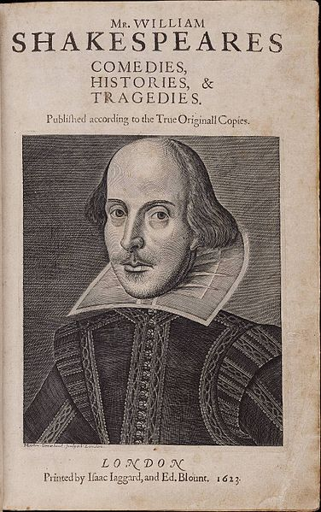  Title page of the First Folio, by William Shakespeare, with copper engraving of the author by Martin Droeshout, 1623. This was the first collection of Shakespeare's work that was printed after his death.  Image is courtesy of Wikimedia Commons and is public domain.
6. Who was William Shakespeare? | 8. What influence has Shakespeare had on modern culture?
7. Why were Shakespeare’s plays so popular?

FA | SQ 8: What cultural effects did the Renaissance and the printing press have in northern Europe?  ➡ Directions: Using evidence from above, complete the Combined Context Expansion Sentence activity below to provide context for the cultural effects the Renaissance and printing press had on northern Europe. An example using the Fall of Rome is provided.

Contextualize  Connect Cause and Effect | Example: The Mongol Empire gained, consolidated, and maintained power throughout Asia during the 13th century.  Who? Mongol Empire  When? 13th century  Where? Asia and Eastern Europe  How? Repeated military campaigns, superior weaponry, religious toleration for conquered people  Combined Context Expansion Sentence 1 Throughout the 13th century, the Mongol Empire which stretched across Eastern Europe and most of Asia gained, consolidated, and maintained power by using repeated military campaigns, superior weaponry, and implementing religious toleration for conquered people. Writing Strategies Used: Prepositional phrase (Throughout the 13th century,) Conjunctions (by, and)  Combined Context Expansion Sentence 2 The Mongol Empire, a state that stretched across Eastern Europe and most of Asia in the 13th century, maintained power by using repeated military campaigns, superior weaponry, and implementing religious toleration for conquered people. Writing Strategies Used: Appositives (..., a state that stretched across Eastern Europe and most of Asia in the 13th century,...) Conjunctions (by, and)  Event: The Renaissance and printing press had cultural effects on northern Europe  Who?  When?  Where?  Why?  How?  Combined Context Expansion  Sentence

